Name: Aarushi Raizada
Batch: A1
PRN: 25070122002
Subject: Programming with Java
ASSIGNMENT No :3
TITLE : Develop a Java application demonstrating method overloading and the use of static
variables, methods in class design.

Problem Statement
Develop a Java application demonstrating method overloading and the use of static variables,
methods in class design.

Learning Objectives
To implement method overloading and use static variables and methods in Java programs.

Theory
Method overloading allows multiple methods to have the same name with different parameter lists, enabling compile-time polymorphism. The static keyword is used for variables and methods that belong to the class instead of individual objects. Static members share common data among all objects and reduce memory usage. These concepts improve code flexibility, readability, and efficient resource management.

Exercise
1. Develop a Calculator program using overloaded methods for addition of integers and
decimals. Use a static variable to count calculations.
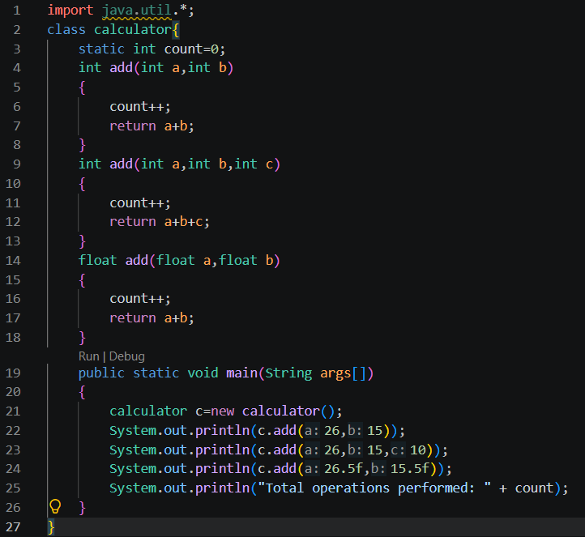

OUTPUT
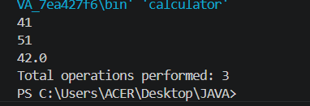

2. Develop a Restaurant Billing Application where overloaded methods calculate bills for
dine-in, takeaway, and delivery orders, while static variables track total orders.

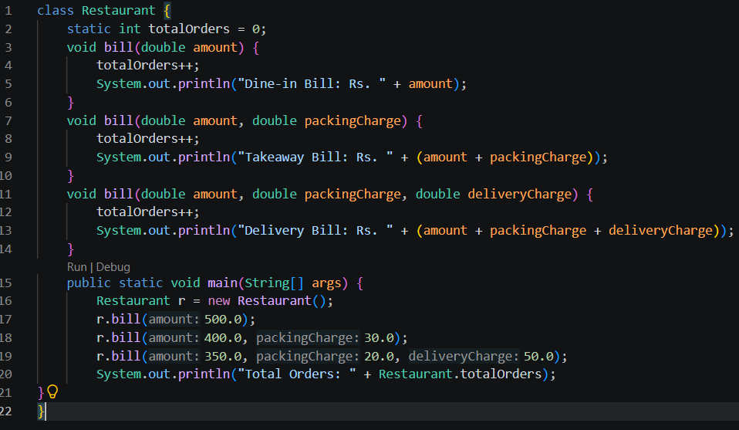

OUTPUT
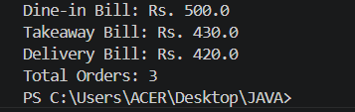
Conclusion
In this experiment, we learned how to implement method overloading in Java by creating multiple methods with the same name but different parameter lists. It demonstrated how method overloading improves code reusability, readability, and flexibility while allowing the same operation to work with different types of inputs.

